International dollars

International dollars are a hypothetical currency that is used to make meaningful comparisons of monetary indicators of living standards.Figures expressed in constant international dollars are adjusted for inflation within countries over time, and for differences in the cost of living between countries.The goal of such adjustments is to provide a unit whose purchasing power is held fixed over time and across countries, such that one international dollar can buy the same quantity and quality of goods and services no matter where or when it is spent.

https://ourworldindata.org/international-dollars
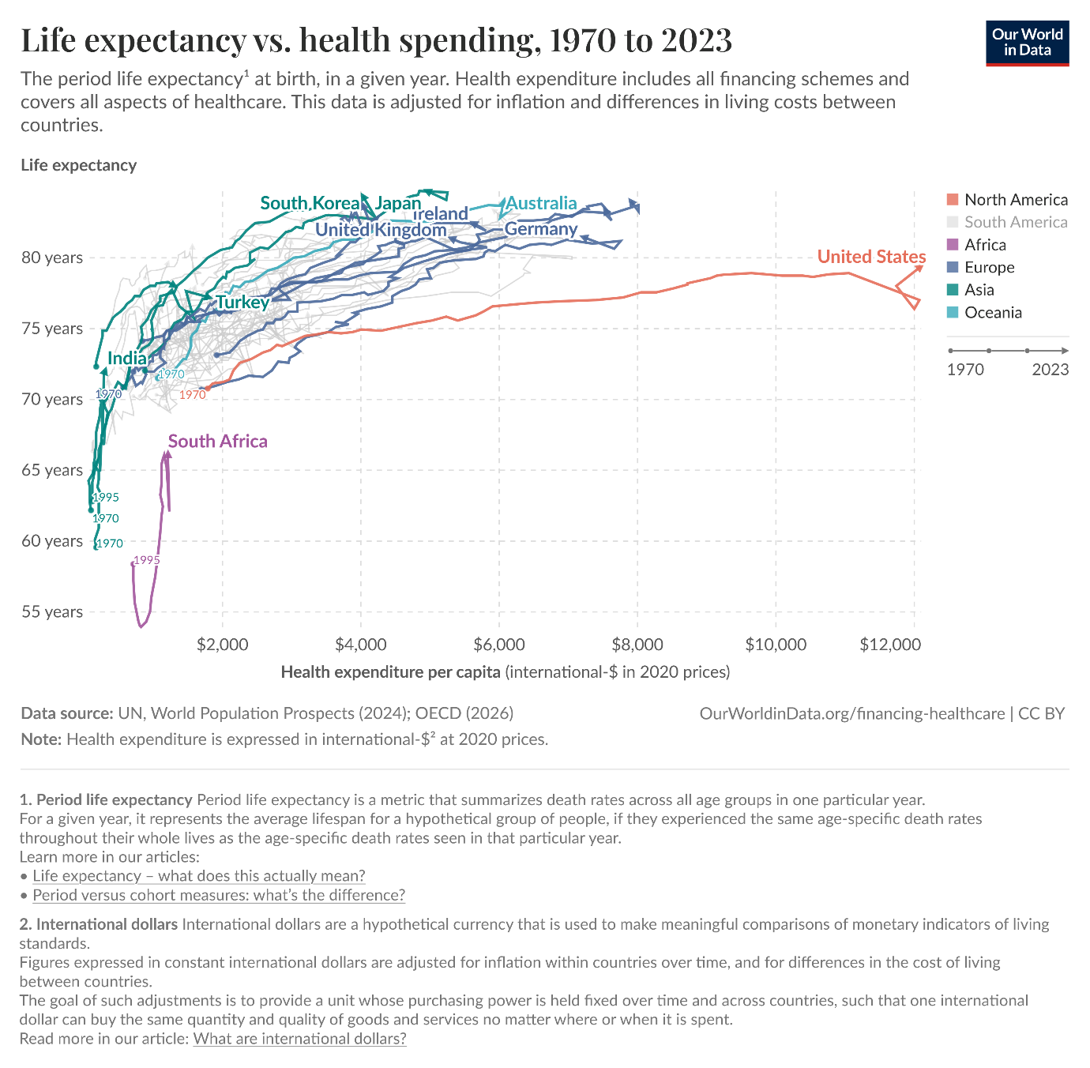

Source and citation
Data sources:
- UN, World Population Prospects (2024)
- OECD (2026)
- Our World in Data
– with minor processing by Our World in Data
Citation guidance: Please credit all sources listed above. Data provided by third-party sources through Our World in Data remains subject to the original providers' license terms.

